D: 18/07/2020

NACL :

--> We need to takes care about the Inbound rules and outbound rules.

--> We need to open ephemeral ports.

--> We have ALLOW / DENY option.

--> Lowest rule will have highest priority.

https://docs.aws.amazon.com/vpc/latest/userguide/vpc-network-acls.html#nacl-ephemeral-ports

____

VPC Peering : It enable us to establish connectivity between multiple VPCs.

--> VPC is a Non-Transitive peering.

--> Source and Destination networks/VPCs should not contain same IP ranges.

Requester VPC Info AccepterVPC Info

CIDR 192.168.0.0/16 172.31.0.0/16

VPC ID vpc-02fbca21f99732317 vpc-0c84f896a6c0bb6fe

Region ap-south-1 us-east-1

Aws Acc num

Edit mumbai rt with NV IP address via PCX.

Edit NV rt with Mumbai IP address voa PCX.

__________

Endpoints:

Gateway endpoint : s3 and DynamodB

Enable VPN Connectivity : https://www.youtube.com/watch?v=JSTyjISscNg

Transit Gateway : https://www.youtube.com/watch?v=xyLlMBHy2wc

ssh -i keypair.pem ec2-user@ipaddress

--> For IPv6, TO provide interenet to private subnet instance we cannot use NAT Gatreway.. We use "Igress Only Interent Gateway"

---------------------------------------------------------------------------------------------------------------------------------------

Certification Questions:

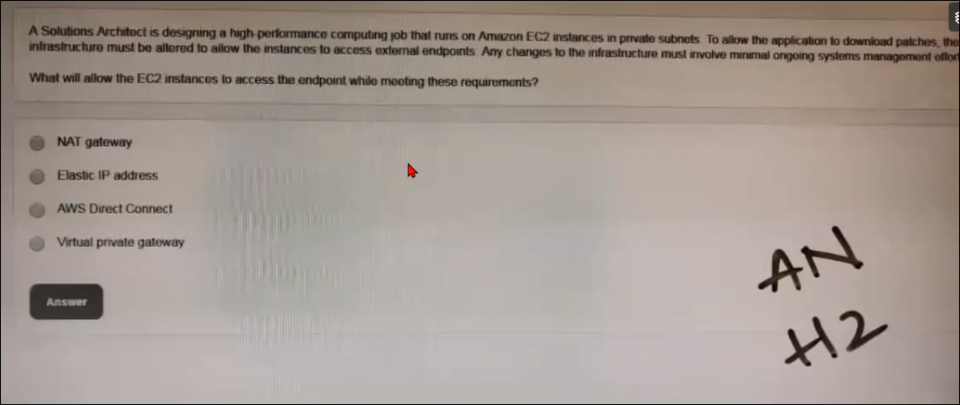

Ans : A , NAT Gateway

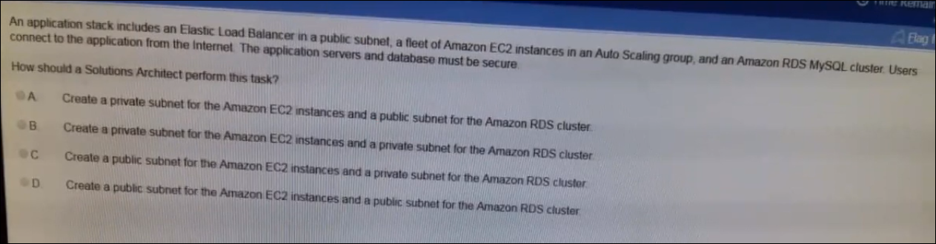

Already they mentioned that ELB is in Public subnet, then ans will be “B”, if they haven’t mentioned this ELB in public Subnet then it will be “C”.

For more security we run the web servers and DB in Private subnet.

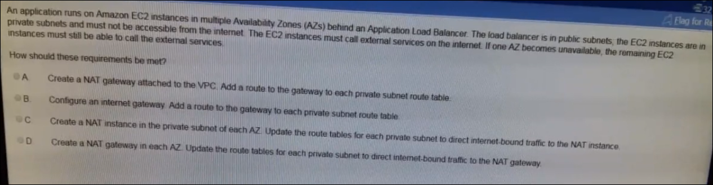

Ans “D” .

We don’t connect NAT Gateway directly to VPC – no [ A]

Internet gateway doesn’t make our private instace to get internet , -- no [B]

NAT Instance is connect to public not private – NO [ C]

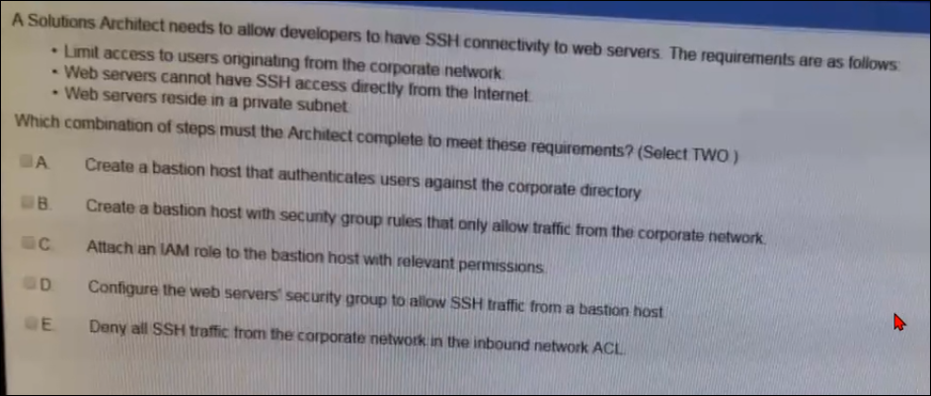

ANS “B” & “D”.

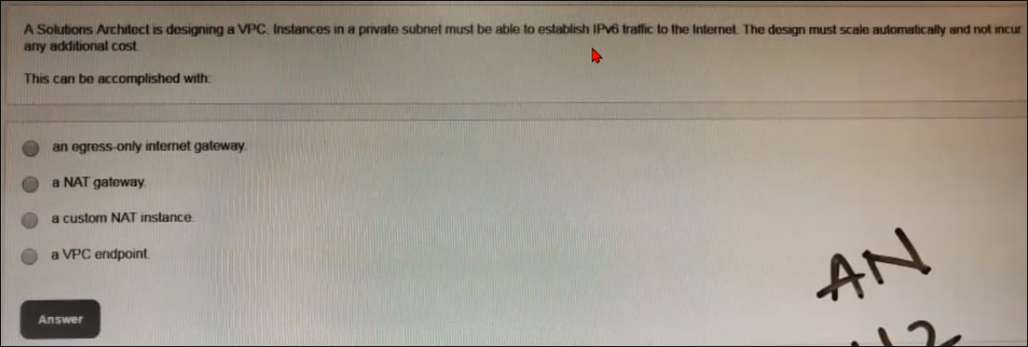

Ans : “A”

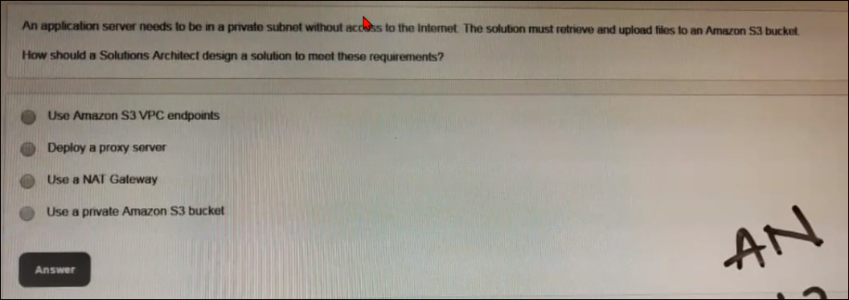

Ans: “A”

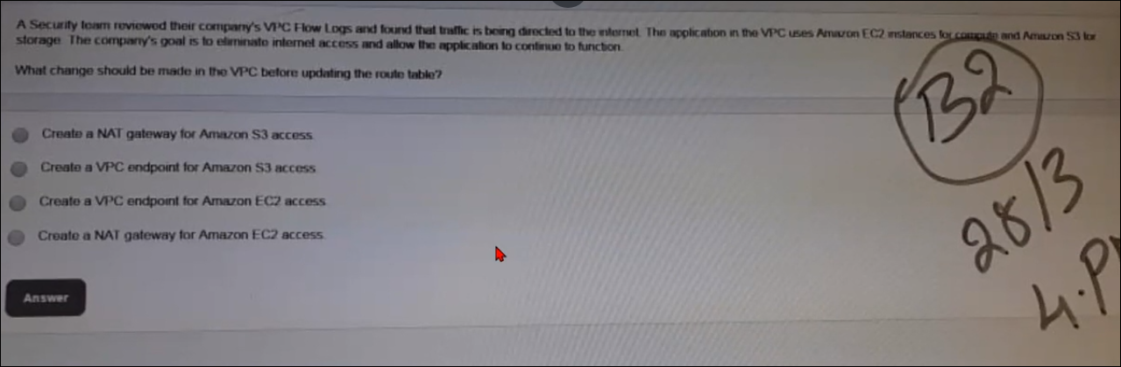

Ans “ B”

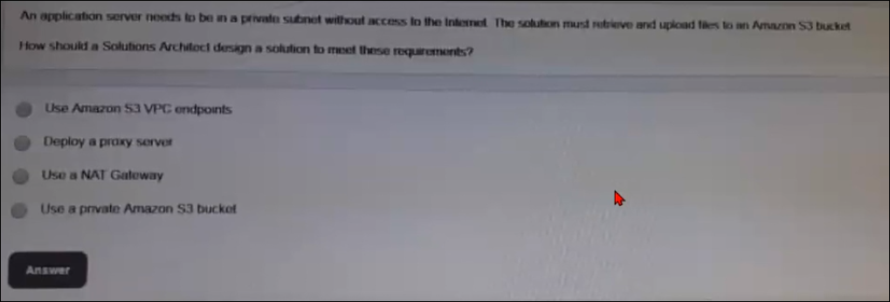

Ans : “A”